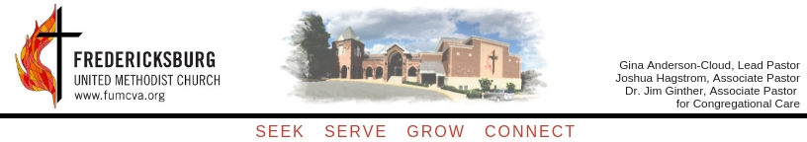

November 4, 2020

Dear FUMC Family,

We pray this letter finds you safe and well during these unusual times. As we head into the final two months of the year, your church leadership is working diligently to make ministry plans for the following year amongst all the uncertainty. We truly are taking a step out in faith, not knowing what the new year holds, but your support goes a long way in helping us complete this task.

Enclosed with this letter is a pledge card where you may make a financial pledge to the church for the upcoming year. Your pledges help the church estimate how much revenue to expect and allow us to craft our ministry budgets. Pledge cards can be returned at any time. You can make a pledge using the Simple Church app or mail them to the church at: 308 Hanover Street Fredericksburg VA 22401. For those who can attend, pledge cards will also be collected during worship service on November 22nd. If you have any additional questions, please contact our membership secretary, Michelle Cooper, at michellecooper@fumcva.org or (540)373-9021, ext. 103.

You will note on the Pledge Card that our campaign to retire the debt on Kobler Hall has been rebranded for the upcoming year. As we put “20/20” in the rearview mirror, we return to “Lift High the Cross,” the name of a campaign that ended in 2005. That campaign allowed for the vision of a new place to expand our ministry to be realized. That campaign raised over half a million dollars over a 2-3 year period. Below is the Hymn which I encourage you to read.

Lift high the cross, the love of Christ proclaim, till all the world adore his sacred name.
Come Christians, follow this triumphant sign. The hosts of God in unity combine.
Each newborn servant of the Crucified, bears on the brow the seal of him who died.
O Lord, once lifted on the glorious tree, as thou hast promised, draw the world to thee.
So shall our song of triumph ever be. Praise to the Crucified for victory.
Lift high the cross, the love of Christ proclaim, till all the world adore his sacred name.

Kobler Hall has been such a blessing to all our ministries and has allowed our church to reach out to the community and foster growth within our church by literally lifting high the message of Jesus. Our hope is that the “Lift High the Cross” campaign will bring everything full circle so we can close out the debt on Kobler Hall, freeing up your gifts for additional ministry opportunities. Our debt balance stands at $724,000. Please consider a pledge toward reducing this debt.

While giving has been faithful during this health crisis, we did not have to make our monthly principal payments for Kobler Hall which has allowed us to break even most months. (Giving designated to the 20/20 campaign was still applied solely to principal.) We do not know whether this principal reprieve can continue into the new year. Additionally, we are using federal relief funding to ensure fulfillment of our obligations to the global United Methodist Church. That said, we are seeing some decline in both attendance and giving numbers; our end of year giving usually comprises 20% of our yearly giving. We are asking you all to pray for our church for the months ahead and give as the Lord leads you. For those who may receive additional tax benefits for charitable giving, we will provide additional information by letter soon or you can always feel free to reach out to us or our financial staff.

Finally, we want to offer our sincere appreciation for your continued generosity and faithfulness through the past year. It certainly has been a difficult year for everyone, and we thank you for allowing our ministries to continue in ways that truly reveal God’s grace day to day.

Grace and peace in Christ,

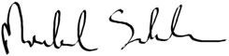

Rev. Gina Anderson-Cloud Mike Sienkowski
Senior Pastor Finance Chair

Enclosure: 2021 Pledge Card

